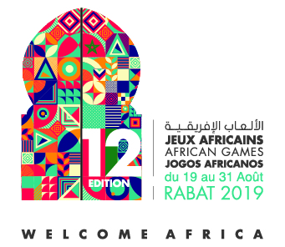
Media Enrollment and Registration
I, the undersigned :
Quality:
(Director, CEO, etc.)
Of the Press Organization:
To have appointed Mr:
To be accredited as a representative of our organization to cover the African Games Rabat 2019.
Information about the person to be accredited
Mr Mrs
Last Name : | First Name :
Nationality : | CIN / Passport No. :  Attach a copy of the document
Mobile Phone / Landline Phone : | Email :
Name of the media support | Address of the media support
Number of the press card | Validity of the press card
Country: | City:
Professional Mobile Phone : | Professional Fax :
Type of media | - Press Agency  - Print Media  - Electronic Press  - Radio  - Television
Frequency | - Daily  - Weekly  - Monthly  - periodic
Function : | - Journalist  - Photographer  - Cameramen  - Technician
Last name :
Media Stamp

First name :
Quality :
Signature :

To this end, COJAR requests the media organizations wishing to cover this event to kindly fill out the attached accreditation form and return itbefore June 30thby e-mail to the following address :
Accreditation-presse@jar2019.ma
relations-presse@jar2019.ma

